# Script to configure Atlas Hive hook by transferring tarball and atlas-application.properties from master1 to edge1,

# extracting tarball to /opt, and copying JARs to Hive lib on edge1

# --- master1 (192.168.22.10) ---

# 1. Transfer tarball and atlas-application.properties to edge1

echo "Transferring tarball and atlas-application.properties from master1 to edge1"

su - hadoopZetta

scp /home/u1/apache-atlas-2.4.0-hive-hook.tar.gz hadoopZetta@192.168.22.17:/home/hadoopZetta/

scp /opt/apache-atlas-2.4.0/conf/atlas-application.properties hadoopZetta@192.168.22.17:/home/hadoopZetta/

exit

# --- edge1 (192.168.22.17) ---

# 2. Verify tarball

echo "Verifying tarball on edge1"

su - hadoopZetta

cd /home/hadoopZetta

ls -l apache-atlas-2.4.0-hive-hook.tar.gz

exit

# 3. Extract tarball to /opt

echo "Extracting tarball to /opt on edge1"

su - root

cd /home/hadoopZetta

tar -xvzf apache-atlas-2.4.0-hive-hook.tar.gz -C /opt/

rm -rf /opt/apache-atlas-2.4.0/hook/hive/*

mkdir -p /opt/apache-atlas-2.4.0/hook/hive

cp -r /opt/apache-atlas-hive-hook-2.4.0/hook/hive/* /opt/apache-atlas-2.4.0/hook/hive/

chown -R hadoopZetta:hadoopZetta /opt/apache-atlas-2.4.0/hook

chmod -R 755 /opt/apache-atlas-2.4.0/hook

ls -l /opt/apache-atlas-2.4.0/hook/hive/

exit

# 4. Copy hook JARs to Hive lib

echo "Copying hook JARs to Hive lib on edge1"

su - root

cp /opt/apache-atlas-2.4.0/hook/hive/atlas-hive-hook-2.4.0.jar /opt/apache-hive-3.1.3-bin/lib/

cp /opt/apache-atlas-2.4.0/hook/hive/atlas-plugin-classloader-2.4.0.jar /opt/apache-hive-3.1.3-bin/lib/

cp /opt/apache-atlas-2.4.0/hook/hive/hive-bridge-shim-2.4.0.jar /opt/apache-hive-3.1.3-bin/lib/

cp -r /opt/apache-atlas-2.4.0/hook/hive/atlas-hive-plugin-impl /opt/apache-hive-3.1.3-bin/lib/

chown hadoopZetta:hadoopZetta /opt/apache-hive-3.1.3-bin/lib/atlas-*.jar

chown -R hadoopZetta:hadoopZetta /opt/apache-hive-3.1.3-bin/lib/atlas-hive-plugin-impl

chmod 644 /opt/apache-hive-3.1.3-bin/lib/atlas-*.jar

chmod -R 755 /opt/apache-hive-3.1.3-bin/lib/atlas-hive-plugin-impl

ls -l /opt/apache-hive-3.1.3-bin/lib/atlas*

exit

# 5. Configure hive-env.sh

echo "Configuring hive-env.sh on edge1"

su - root

echo "export HIVE_AUX_JARS_PATH=/opt/apache-atlas-2.4.0/hook/hive" > /opt/apache-hive-3.1.3-bin/conf/hive-env.sh

chown hadoopZetta:hadoopZetta /opt/apache-hive-3.1.3-bin/conf/hive-env.sh

chmod 755 /opt/apache-hive-3.1.3-bin/conf/hive-env.sh

cat /opt/apache-hive-3.1.3-bin/conf/hive-env.sh

exit

# 6. Move atlas-application.properties to Hive conf

echo "Moving atlas-application.properties to Hive conf on edge1"

su - root

mv /home/hadoopZetta/atlas-application.properties /opt/apache-hive-3.1.3-bin/conf/

chown hadoopZetta:hadoopZetta /opt/apache-hive-3.1.3-bin/conf/atlas-application.properties

chmod 644 /opt/apache-hive-3.1.3-bin/conf/atlas-application.properties

cat /opt/apache-hive-3.1.3-bin/conf/atlas-application.properties

exit

# 7. Restart Hive services

echo "Restarting Hive on edge1"

su - root

pkill -f HiveServer2

/opt/apache-hive-3.1.3-bin/bin/hiveserver2 &

exit

# On master1

echo "Restarting Hive metastore on master1"

su - root

pkill -f HiveMetastore

/opt/apache-hive-3.1.3-bin/bin/hive --service metastore &

exit

# On master2

echo "Restarting Hive metastore on master2"

su - root

pkill -f HiveMetastore

/opt/apache-hive-3.1.3-bin/bin/hive --service metastore &

exit

# On master3

echo "Restarting Hive metastore on master3"

su - root

pkill -f HiveMetastore

/opt/apache-hive-3.1.3-bin/bin/hive --service metastore &

exit

# 8. Test Hive

echo "Testing Hive on edge1"

su - hadoopZetta

hive <<EOF

CREATE DATABASE test_db;

USE test_db;

CREATE TABLE test255 (id INT);

exit

# 9. Import Hive metadata

echo "Running import-hive.sh on edge1"

su - hadoopZetta

export HIVE_HOME=/opt/apache-hive-3.1.3-bin

export ATLAS_HOME=/opt/apache-atlas-2.4.0

/opt/apache-atlas-2.4.0/hook-bin/import-hive.sh

exit

# 10. Check Atlas

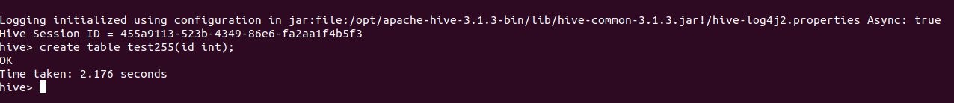echo "Verify in Atlas UI at http://192.168.22.10:21000 or http://192.168.22.11:21000"

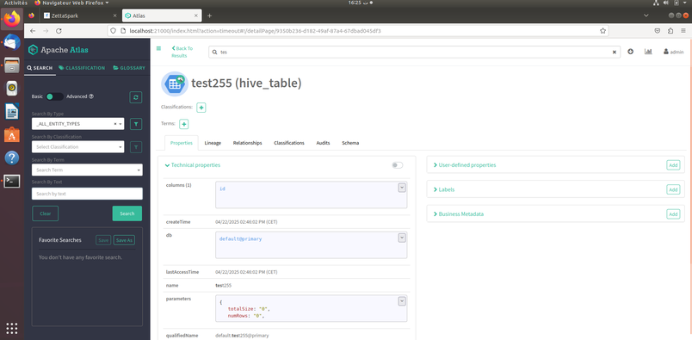

########### And Now Hive Working Smoothly###########